Kol Simcha Torah Gazette
For Parshas ki sisa 5786
Vol 10 Issue 22 (Whole #488) 11 Adar 5786/ March 7, 2026
Printed L’illuy nishmas Nechama bas R’ Noach, a”h
For a free subscription, please forward your request to keren18@juno.com
Past emails can be found on the website ShabbosStories.com under Brooklyn Torah Gazette

Purim and the War
Against Iran
By Miriam Malka Frankel

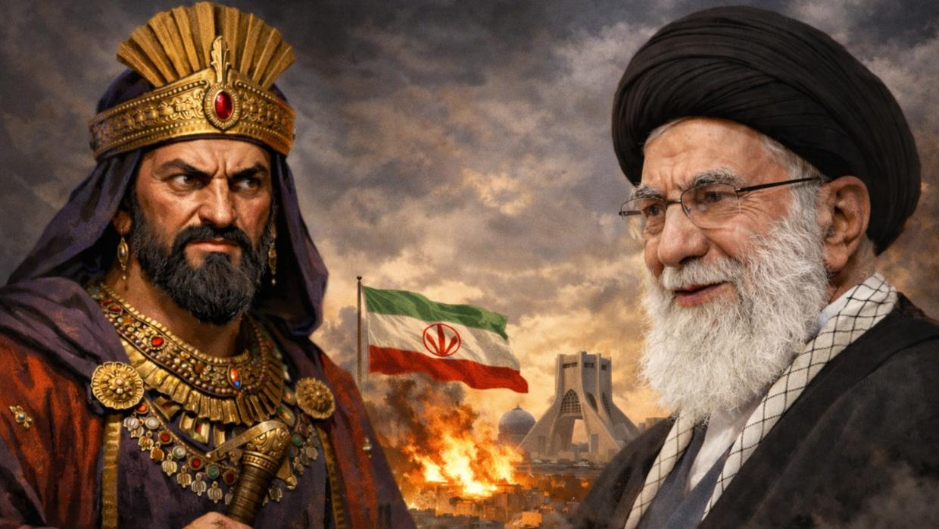

As Jews prepare to celebrate Purim this year, the ancient story of the defeat of Haman who ordered a decree to annihilate the Jewish people feels less like history and more like a headline.
On the 14th of Adar, 356 BCE, the Jewish holiday of Purim was observed for the first time, commemorating the survival of the Jewish people under Persian imperial rule and the defeat of a decree calling for their annihilation. As Jews around the world prepare once again to mark Purim, the ancient story carries an uncomfortable familiarity, alongside a measure of hope.
The Book of Esther tells the story of King Ahasuerus and his rise of his chief minister Haman, who uses royal favor to issue a decree of extermination against the Jewish people. Haman's hatred was rooted in a blood feud between his people, the Amalekites, and the Jews stretching back centuries.
The decree is reversed not through military genius or diplomatic triumph, but through something harder to explain: a string of seemingly random events, each one unremarkable on its own, that together add up to something that can only be called a miracle.
Look at the chain. Esther becomes queen — not because she sought power, but because the previous queen was deposed for refusing the king's command. Mordecai happens to overhear a plot to assassinate the king and reports it, a small act that gets recorded and then forgotten. Haman, consumed by rage at Mordecai's refusal to bow, builds a gallows and goes to the king at night to request Mordecai's execution. But the king can't sleep that same night, and orders his servants to read to him from the royal chronicles.
They open, at random, to the exact passage about Mordecai saving the king's life — the favor that was never repaid. By morning, when Haman arrives to ask for Mordecai's death, the king is already asking how to honor him. Haman ends up leading Mordecai through the streets in royal celebration. The gallows he built for Mordecai becomes the instrument of his own execution.
No single event looks like salvation. Every step along the way could have gone the other way. Taken together, they form something unmistakable.
That is the hidden hand the Megillah is pointing to. God's name never appears in the Book of Esther. But the architecture of the story makes the presence undeniable. What looks like coincidence, read in sequence, is anything but. Venahafoch hu — "it was turned upside down." The condemned became the victors. Everything that was meant to destroy the Jews became the mechanism of their rescue.

The Ancient Story Playing Out Now
Shushan, the very city at the heart of the Purim story, sits in what is today Iran. We are in the midst of witnessing a moment of “venahafoch hu” – of things being turned over -- right now.
The Islamic Republic of Iran has been the world's leading state sponsor of terrorism, fueling proxy wars, arming terror groups, and spreading violence across the Middle East and beyond. For nearly four decades, its Supreme Leader positioned himself as the ideological heir to the annihilationist hatred the Jewish tradition names "Amalek." He openly and repeatedly called for the destruction of Israel and the death of the Jewish people. And like Haman, Khamenei did not survive to see those ambitions realized.
Ayatollah Ali Khamenei, the leader of this murderous regime, died on Shabbat Zachor, the Sabbath immediately before Purim, when Jews around the world fulfill the Torah commandment to remember what Amalek did to the Jewish people. The timing is not something a novelist would dare invent. His end carries the unmistakable resonance of venahafoch hu.
Khamenei spent decades declaring war on the Jewish people, on America, on Western civilization itself. He was taken down by the very forces he sought to destroy.

The Danger Is Not Over
The Iranian regime's collapse, if it continues, would be one of the most significant geopolitical shifts in a generation. But we are not there yet. The situation is fluid and dangerous. Retaliation is already underway. The regime's proxies — Hezbollah, Hamas, the Houthis — still have weapons, funding, and intent. A weakened but cornered Iran may strike harder before it falls.
The Iranian regime has spent decades building nuclear infrastructure aimed at one purpose: a weapon capable of killing millions of Jews.
The Iranian regime has spent decades building nuclear infrastructure aimed at one purpose: a weapon capable of killing millions of Jews. It has funded every major terror organization targeting Israel and American interests in the region. It has murdered its own citizens for demanding basic rights. A regime this committed to destruction does not reform. It must be dismantled. Half-measures and negotiations have bought time, but time is running out. The window to act, before Iran crosses a nuclear threshold, is narrow. Israel and the United States share both the capability and the moral obligation to close it.

The Call to Every Jew
The closeness of all this to Purim demands our attention.
The story of Esther is, at its core, a story about what happens when people refuse to look away. Mordecai could have kept his head down. Esther could have stayed silent. Instead, they acted, and their actions became the vessel through which something larger moved.
Modern-day Esthers and Mordecais are out there — the dissidents inside Iran risking their lives, the intelligence officers who moved in silence, the leaders who held lines others wanted to abandon, the journalists who refused to normalize evil. Human responsibility was not hidden in Esther's time, and it is not hidden now.
That is the call for Jews today, religious or not: come together and pray.
But there is something else the Purim story demands of ordinary Jews. Before Esther went to the king, she asked Mordecai to gather every Jew in the city to fast and pray together for three days. That communal gathering, that act of unity and serious prayer, was the foundation on which everything else rested.
That is the call for Jews today, religious or not: come together and pray. The act of showing up together as a people, across every difference, carries a weight the Purim story has already proven.
Throughout Jewish we have faced Hamans and Khameneis. Each believed he was writing the final chapter for the Jewish people. Each turned out to be a footnote.
We are watching something unfold in real time. How it ends is not yet clear. But the resonance with this season is too precise to ignore.
I look forward to Purim this year, and to the day Iran is finally free.

Reprinted from the March 1, 2026 website of aish.com

Children Celebrating Purim in Stamford Hill (London) UK

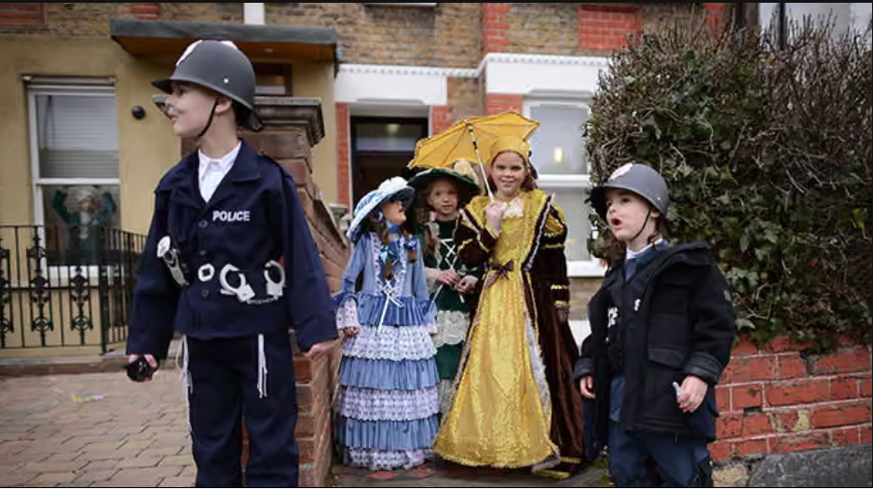

2013 Photo by Stefan Rousseau for The Guardian newspaper in U.K.

The Challenge and Difficulty to Jews Today in Understanding the Terrible Sin of the Golden Calf
From the Teachings of the Lubavitcher Rebbe
Rabbi Menachem Mendel Schneerson, Zt”l

This week's Torah portion, Ki Tisa, contains one of the most misunderstood occurrences in the Torah - the sin of the Golden Calf.
This sin was so great that its consequences are still being felt today, 3300 years later. For, as a result of the sin, G-d promised that every punishment that would ever befall the Jewish people would contain an element of chastisement for this grievous transgression.
And yet, as it appears in the Written Torah (without the accompanying commentary), the entire account is difficult to understand. How could the same people who had just left Egypt under miraculous circumstances, received the Torah at Mount Sinai amidst open miracles and actually heard the voice of G-d utter the first two of the Ten Commandments, actually worship a molten image?
Closer study reveals, however, that the Jewish people were not seeking a substitute for G-d in the Golden Calf; what they desired was a substitute for Moses, as expressed in the verse, "And the people saw that Moses was delayed in coming down ...and they said [to Aaron]: Get up, make us a god...for this man, Moses, who has taken us out of the land of Egypt, we do not know what has become of him."
Without Moses, the Jewish people felt lost. Moses was the intermediary that connected them to G-d, as it states, "I stand between you and G-d." Moses was the medium through which the Children of Israel were freed from Egypt and through whom they received the Torah, to the point where "the Divine Presence spoke from his throat."

A Man of G-d
Moses is referred to as "a man of G-d," for despite the fact that he was mortal, Moses existed on a spiritual plane on which he was totally united with the Divine. His function as intermediary between man and G-d served to strengthen the Jews' belief in the Creator, for it is difficult to believe in a G-d one cannot see. When the Jews beheld a human being on such a G-dly level, it strengthened their faith in G-d and connected them to Him in a tangible manner.
In this light, the mistake they made is far easier to comprehend. When Moses did not reappear when they expected him, the Jewish people feared they had lost the means by which they bound themselves with the Infinite.
They rightly understood that such an intermediary needs to be completely united with G-d; having just witnessed the giving of the Torah on Mount Sinai, at which G-d descended in a "supernal chariot" bearing the face of an ox, they decided to forge a calf of gold that would closely resemble it.

Understanding the Error of Jews at That Time
The Jewish people were correct in their recognition of the need for an intermediary between man and G-d in the form of a G-dly human being; there was also nothing wrong with their choice of an inanimate object to draw holiness down into this world (G-d's voice would later issue forth from between the cherubim - fashioned in the form of two angels - above the holy ark in the Sanctuary).
Rather, their error was in taking into their own hands a matter that can only be determined by G-d. Only G-d can decide how His holiness will be transmitted; only He may choose the correct medium.

Reprinted from the Parashat of Ki Tisa 2025/5785 edition of L’Chaim, a publication of the Lubavitch Youth Organization. Adapted from the teachings of the Lubavitcher Rebbe, zt”l.

Rav Avigdor Miller on the
Impact of Haman and Ayatollah Khomeini

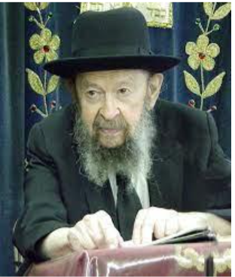

QUESTION: What does it mean when you said the act of putting the king’s ring on Haman’s finger was a benefit for the Jewish nation?
ANSWER: Now we come to the story of one of the greatest benefactors in our history, a man who helped us most, accomplished more than anybody else and that’s our friend, Haman. He’s truly our friend. The Gemara says that Haman accomplished more than all 48 nevi’im.
What Haman did for us, nobody could accomplish for us. גדולה הסרת טבעת – how great was that moment when the ring was taken off the king’s finger and was put on the finger of Haman, יותר – was more than the teachings, than the rebukes and the guidance of 48 nevi’im. Because we did a big teshuva because of that.
So now we know why Haman was there. אחרי כן גידל המלך אחשורוש את המן. Why did the melech elevate Haman? Not the melech Achashveirosh. HaMelech Hakodosh Boruch Hu elevated Haman because He wanted to accomplish a tremendous achievement for His people. You have to understand that.
Now, the time that Haman became the mishneh lamelech, it was very difficult for people to think it’s a benefit of the Am Yisroel. The tzorer haYehudim, now he’s wearing the king’s ring and he can stamp any kind of decree that he wants and he’s known as the tzorer haYehudim. What’s worse for us than that? And we fasted for three days and three nights as a result of Haman’s ascendency to power. But now we know the results, that the Am Yisroel gained such a perfection of character as a result, they did such a teshuvah, there was never before or after equal, even at Matan Torah. It was outdone by Haman! וקימו וקיבלו היהודים – it was even a bigger kabolas haTorah.
Of course, Haman wasn’t the one who gave us the push. Hakodosh Boruch Hu gave us a push. Only He pushed us with a stick. The stick was Haman.
I’ll tell you. A similar thing happened not too long ago in Persia. Jews lived comfortably in Persia. There was a Shah. There was law and order. It was comfortable. Jews were making a living, some were wealthy. And very many were going lost. They lived in peace. Nobody bothered them and that’s why they were going lost. They didn’t have yeshivos in Iran. They didn’t know anything. They were very ignorant.
So along came a meshugener, Khomeini, alav hashnubbel, and he made a revolution, and the Shah had to run away to save his life. And now the Iranians became very big adversaries of the Jews. Great hatred. And the Jews fled. They understood that from now on, it won’t be safe in Persia. When the Shah was deposed so he fled for his life, and when he fled, Jews began to flee too. Everybody had to run to save his life.
But they saved more than their lives. Because the Jews who fled from Persia, now they had an opportunity to come to the places of Torah which were not present in their previous environment in Iran. They were going lost in Iran. They came to America, some came to Eretz Yisroel and were saved.
The Iranian Jews came to America and now you have Iranian Jews who look like real bnei Torah. Some like chassidim, a big beard with black hats. It would never have happened before. Many talmidei chachamim. Many of them married with frum girls, Iranian girls too, and they have families, frum families. Today there are so many frum Persian boys and girls and they married frum, having children already. They wouldn’t have dreamed of that in Persia. In Iran, they would have been lost. They were lost! It’s mamash a geulah. How did the geulah come? There came Khomeini and he redeemed us from the galus of Iran.
It’s a remarkable story. They have to thank Khomeini! אילו לא היה שם לא היו נגאלים! It’s only because of Khomeini that you have so many frum Iranian boys and girls who are really a credit to our nation. I saw a young man, Iranian. A beard, a black hat, he learns in a kollel. I have derech eretz for him. He told me he’s an Iranian which means a few years ago he was a zero! Iran didn’t have any yeshivas! Today many Iranian couples are raising frum families only as a result of the deposing of the Shah.
And so, the whole revolution was only because of us. Don’t deceive yourself. It’s as true as can be. Now you say not all Iranian Jews became good? It was their fault. Opportunity was offered to them and the good ones became good.
And so, when Haman came to power that awakened the Am Yisroel to teshuvah. Same thing, Khomeini. It wasn’t them of course. It was Hakadosh Baruch Hu and these two wicked people were His stick. But the result was a salvation for the Jews, a kabolas haTorah.

Reprinted from the archives of Toras Avigdor. Transcribed from a classic Thursday night lecture delivered in June 1990.

Celebrating Purim in Bucharest, Romania



Photo taken by Vadim Ghirda for the Associated Press showing Jews listening to the reading of the Megillah for the 2013 article in the UK’s The Guardian newspaper.

Thoughts that Count
for Our Parsha

And the people assembled themselves together around Aaron, and said to him: "Get up, make us gods." (Ex. 32:1)
Why did they ask this of Aaron instead of just appointing him in Moses' stead? The answer is that Aaron, "the pursuer of peace," was too close to the people for them to consider him as their leader. Too much familiarity makes it impossible for people to feel the proper respect for their leaders. (Rabbi Yitzchak of Vorka)

You shall see My back, but My face shall not be seen (Ex. 33:23)
According to Rashi's commentary, G-d showed Moses the "knot of the tefilin (phylacteries)." What are we to learn from this? Tefilin consist of two parts - one placed on the hand, and the other on the head. The hand represents interpersonal relationships, for it is with our hands that we extend aid and assistance to others, whereas the head, the seat of our intellect, is the medium through which we connect ourselves to G-d by learning His Torah. In order to serve G-d properly, the Jew must excel in both areas. Moses asked to see G-d's glory so that he would have a better understanding of what is required of the Jewish people. The knot of the tefilin symbolizes G-d's desire that every Jew bind these two aspects of our worship together - doing our utmost for our fellow Jews and at the same time devoting ourselves to Torah study. (Our Sages)

And he saw the calf and the dancing, and the anger of Moses waxed hot, and he threw the tablets from his hands (Exodus 32:19)
This underscores the difference between hearing about something and actually seeing it for oneself. Although G-d had already informed Moses of the Jews' transgressions, his reaction was more extreme once he had seen their behavior for himself.

When you shall take the sum (literally, "the head") of the Children of Israel... then shall they give every man a ransom for his soul (Ex. 30:12)
When the time will come for you to appoint a "head" - a leader of the Jewish people - make sure it is one who is willing to give up his very soul on behalf of his brethren; only one such as this is worthy. (Alshich)

Reprinted from the Parashat of Ki Tisa 2025/5785 edition of L’Chaim.
Toxic Positivity and Real Life
By Tzvi Freeman



Is happiness stupid?
Here’s the quandary. Take poor, confused Tonya. Tonya turned up at the Chabad House one Tuesday when Rebbetzin Chaya was giving a class on “think good and it will be good.”
It was just the mantra Tonya was looking for. She spent that week chanting to herself, again and again, “think good and it will be good.”
She chanted it as she studied for her exam—and she aced that exam. She chanted it before asking for a vacation—and she got her vacation.
Then she went to visit a friend who was sitting shivah, in mourning for her mother. Tonya told her friend, “Think good and it will be good.”
But her friend said, “Tonya, I’m in mourning now for my mother.”
Then came next Tuesday at Chabad. Rebbetzin Chaya spoke about how the Jewish people have always prayed and longed for the times of Moshiach. She sighed and concluded, “We need Moshiach now!”
“Rebbetzin!” Tonya exclaimed. “Think good and it will be good!”
But the rebbetzin answered, "Sometimes we need to feel the pain.”

Life As Paradox
You can see Tonya’s confusion: Is life about being positive and happy? Or is it about feeling the emotion of the moment? The emotion of the moment can drag you down. Happiness and positivity can pick you up and make real change. Why can’t we just stay in that bliss 24/7?
But no, there’s no one-size-fits-all in human life. Even when thinking good, there’s got to be some tiny space for crying out about what’s not good. And even when one of those times comes for crying bitterly, there’s got to be something inside you that remains whole and optimistic.
In fact, everything in life requires you to feel the opposite of whatever it is you’re feeling. Sometimes, it’s a sequence. Sometimes, it’s simultaneous.
Sometimes, you can’t get back to life without first going through a period of mourning.
Sometimes, you can’t treasure all you’ve got without first losing some of it.
Sometimes, you can’t feel good about your accomplishments until you’ve fallen flat on your face.
Sometimes, it’s simultaneous.
If you want to be happy about something, you need to be sad about something else. If you want to become big, you need to make yourself small. If you want to feel rich, you need to feel what it means to be poor.
You can only truly feel grateful for the wholesomeness of your life because you’re broken inside and feel you deserve nothing.
You can only feel the real, tremendous joy that you have in a relationship with the Creator of Everything because you feel like nothing in your awe before Him.
You can only feel the sweetness of closeness to G-d that comes with a mitzvah because you feel the bitterness of distance, being just another smushy organism inside a carbon-based shell.
As the Zohar says, “Joy is fixed in my heart from one side, and tears from the other side.”¹ Like an engine driven by a dynamic of two polar charges, bitterness and joy drive one another, feed off one another, and carry you to the highest heights.²

Realistic Optimism
No, the road to happiness is not paved with stupidity. You can’t say, “Ignore the bad. Think only about the good. No matter how hard life slaps you in the face, happiness will carry you over it. No other emotion is needed.”
Rather, you say, “It's a tough world out there. Nature can be awful mean. People are inherently selfish and can do nasty things you can’t imagine. And it’s those people who most often run the show. But I tie myself to the One Above who cares about me like a father cares about his only child. Together, we will turn this ugliness around and make a beautiful world.”
Like David said in his psalm, “I lift my eyes to the mountains. There’s nothing that can help me. My help is from G-d who makes heaven and earth.”³
David recognized how impossibly dire was his situation—and that itself informed him of how great was G-d’s love and His miracles that would save him. Nothing and no one could help—except for the One who created it all, who is beyond something and nothing, and so can do anything.⁴
The true optimist is a realist. Because it’s not a binary world. Yes, the choice comes down to what’s right and what’s wrong, but the good and bad are so deeply intertwined, you can’t deal with one without stepping into the other.
They’re intertwined in your heart. Within the disappointment you feel over your failure, there you can find the strength to succeed. Within the bitterness in your heart for the loss of good friends, there you can find reason to celebrate life and to treasure every encounter with a human being. When your self-esteem is broken, pummeled into the ground, from there you gain the maturity to understand who you really are, what you can accomplish, and to stand proud in your achievements.
You enter within each of these, but with intent, with purpose. Because nothing in life is without meaning. Everything is G-d leading you somewhere by the hand. And that somewhere is always higher than anywhere you have been until now.

Always Happy
Then, beneath every emotion lies the true happiness. Perhaps not a jump-for-glee happiness, but an inner vitality, a spark that glows within the pitch darkness, a drop of honey within bitterness, a wholeness that can’t be divided within the brokenness, even within the mourning and disappointment.⁵
In each, you find that spark that says, “I can do this. I can make it through. Because I’m not alone. Through all this, I have at my side the One who made heaven and earth.”
Indeed, the Jewish people have been doing this since the times of Abraham. We are alive, because in everything, even in our most bitter tears, we celebrate life.
And life ultimately wins when Moshiach arrives, sooner than you can imagine.
Footnotes

1. Zohar III 75a. 2. See Tanya, end of chapter 34. 3. Psalms 121:1-2.
4. Sichos Kodesh 20 Cheshvan 5741. 5. See Tanya, chapter 31.
Reprinted from the current website of Chabad.Org

A Piece of Chocolate:
The Moment He Finally Understood Judaism
By Naama Green



A wealthy businessman attended a Jewish seminar, but no lecture moved him. One child who refused a piece of chocolate showed him what Judaism really means.
Rabbi Avraham Mordechai Malach recounted the story of a wealthy Jew who lived far from Torah and mitzvot. One day he attended a seminar organized by Arachim and returned home a complete baal teshuva.
When people later asked him what had influenced him so deeply, which lecture had touched his heart and brought him closer to Judaism, he surprised them with his answer:
"Not a single lecture convinced me. One piece of chocolate brought me back."
He then explained.
"I own a large factory that produces pralines and chocolates. I often take premium sweets with me, and whenever I meet children I give them out generously. In this way I also do a bit of advertising for my products, because every child who tastes them immediately becomes a loyal fan."

The Child Who Said No
"At the seminar I did the same thing," he continued. "I brought many fine chocolates and handed them out to the children. Then I noticed one boy who still hadn’t received any and wasn’t coming forward like the others. I approached him and asked, 'My dear child, did you get a chocolate?' He said no.
"I asked him if he wanted one, and he said yes. I gave him several chocolates, and he happily took them."
The boy caught his attention, and he decided to watch what would happen next.
"I understood that he was the son of one of the lecturers. He went over to his mother, showed her the chocolates, and asked if he could eat them. She carefully examined them and then said, 'No.'
"And the boy, without a word, without arguing, without asking questions, quietly threw all the chocolates into the trash."

What Yiddishkeit Looks Like
"My eyes filled with tears," the man continued.
"I thought to myself: I’ve been sitting here for days listening to lectures explaining what Judaism is, and nothing really entered my heart. But now, in just two minutes, I saw with my own eyes what Yiddishkeit truly is.
"A child who can say no to something he wants, that is Yiddishkeit."
"That moment drew me in and made me a complete baal teshuva."
He continued: "I thought to myself: I am already sixty years old. When was the last time I told myself no about something I really wanted? Was there ever even one time when I truly controlled my desires?"
"Seeing that child give up the chocolate because it did not have kosher certification filled me with awe. That moment changed my life."

The Real Measure of a Jew
Rabbi Malach concluded:
"There is a powerful lesson here. A person’s true Yiddishkeit is measured by self-control, by the ability to say no when the desire burns strongly.
Whether it is guarding one’s eyes, restraining oneself, or holding back from speaking lashon hara, this is the essence of Judaism."

Reprinted from the current website of Hidabroot

